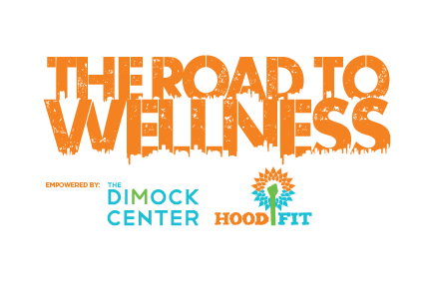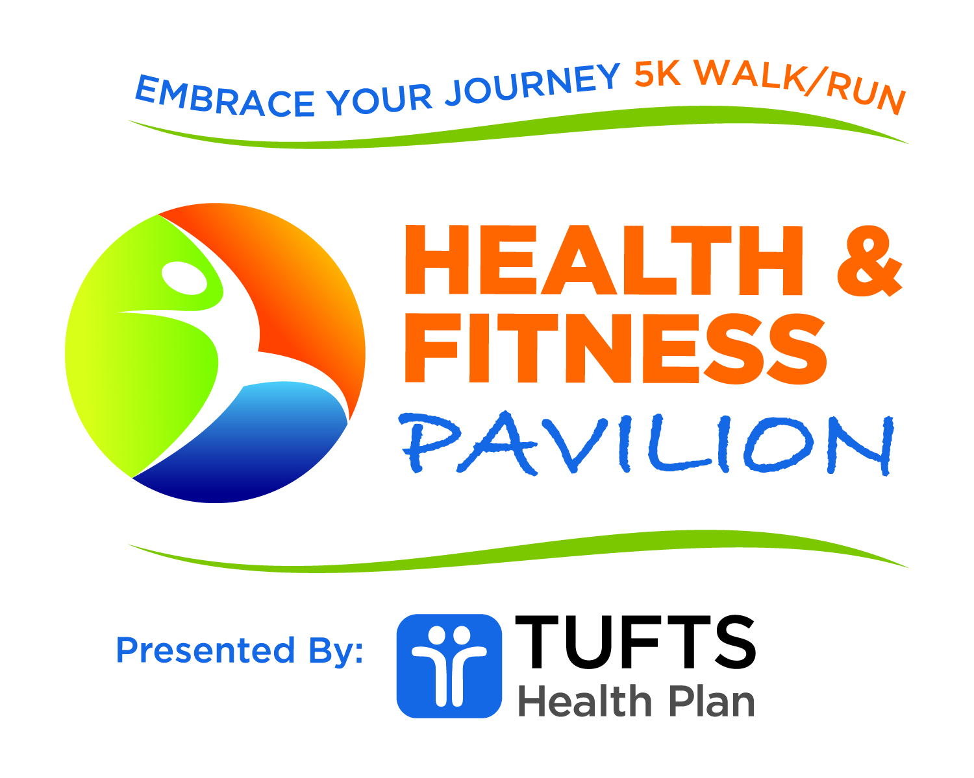
The Road to Wellness Saturday Training Series

Name:
Address:

Phone:
Email:
Date of Birth (mm/dd/yy):
Emergency Contact:
Name:
Phone:

Would you like to register for The Road to Wellness? Yes No
Virtual Timed 5K Virtual 2-Mile Walk Team Name:
Gender:
T-Shirt Size: Youth S Youth L Small Medium Large
X-Large XX-Large

**Please read and sign the Waiver of Liability on the reverse of this page. All registrants are required to bring a copy of this completed form to their first training session.

RELEASE AND WAIVER OF LIABILITY

For consideration of participation in The 5th Anniversary Road to Wellness 5k Walk/Run and all affiliated trainings and activities (collectively, The Road to Wellness), I waive and release The Dimock Center, HoodFit, the Boston Athletic Association (collectively, the “Partners”), their directors, officers, administrators, representatives, past and present employees, volunteers, agents, supervisors, participants, all city and state governments, assigns, all sponsors, their representatives and successors and other persons (collectively, the "Releasees"), from any and all claims, liabilities, or causes of action arising out of an injury to me (or my child) and from any and all claims, liabilities, or causes of action arising from my (or my child's) participation or attendance in this event.
I understand that The Road to Wellness involves strenuous physical activity. I understand that physical activity, by its very nature, carries with it certain inherent risks. I assume all risks associated with participating in The Road to Wellness relating to the risk of strenuous physical activity. I acknowledge that I (or my child) may incur minor injuries, major injuries, and catastrophic injuries including paralysis and death. I assume risks from contact with other participants and volunteers, collisions with other participants, vehicles, and pedestrians, negligent or wanton acts of other participants and volunteers, failure of other participants, volunteers and non-participants from observing the guidelines of The Road to Wellness or any applicable laws, any defects of conditions of premises, and the effects of weather including high heat, thunderstorms, lightning, precipitation, cold temperatures, high winds, and/or humidity.
I assume all risks associated with consuming any food or drink available at the event. I am solely responsible for any adverse health effects from food or beverage consumption, regardless of any allergy, known or unknown, that I (or my child) may have.
I agree to dress myself (or my child) appropriately as to mitigate risk of physical injury to myself (or my child) including, but not limited to: wearing shoes appropriate for physical activity involved in The Road to Wellness; and dressing in conjunction with the weather.
I agree that the Releasees are not responsible for any personal items or property lost or stolen before, during, or after The Road to Wellness.
Weapons are strictly prohibited at this event. I agree not to bring a weapon of any kind to the event, including all Partner sponsored pre and post event activities.
I attest that I (or my child) am medically and physically able to participate in The Road to Wellness. If I experience any doubt as to my (or my child's) ability to successfully and safely participate in and/or complete the event, I take full responsibility for consulting a physician. I attest that, if I (or my child) am pregnant, disabled in any way, or have recently suffered an illness, injury, or impairment, I (or my child) should have or did consult a physician prior to participating in The Road to Wellness.
I consent to emergency medical care and transportation in the event of injury to me (or my child) as medical professionals may deem appropriate. This Release extends to any liability arising out of or in any way connected with the medical treatment and transportation provided in the event of an emergency, including, but not limited to, negligence emergency rescue operations.
I am fully aware of the risks connected with participation in The Road to Wellness, whether specifically listed in this Release or not, and I voluntarily elect to participate in The Road to Wellness knowing that this participation involves these risks.
In consideration for being permitted to participate in The Road to Wellness, I voluntarily agree for myself, my family, heirs, assigns, executors, and administrators to the following:
1. TO ASSUME FULL RESPONSIBILITY FOR ANY RISKS OF LOSS, OR PERSONAL INJURY, INCLUDING DEATH that may be sustained by me (or my child), or any loss or damage to property owned by me (or my child), as a result of participating in The Road to Wellness.
2. TO RELEASE, WAIVE, HOLD HARMLESS, DISCHARGE, AND COVENANT NOT TO SUE the Releasees from any and all liability, claims, actions, demands, expenses, attorney fees, breach of contract actions, breach of statutory duty or other duty of care, warranty, strict liability actions, and causes of action whatsoever, that I might have or may acquire in the future, arising out of or related to any loss, damage, or injury, including death, that may be sustained by me (or my child), or to any property belonging to me (or my child), while participating in The Road to Wellness including, but not limited to, any claim that the act or omission complained of was caused in whole or in part by the negligence or carelessness of the Releasees.
I agree to observe and obey all rules and safety procedures that accompany The Road to Wellness and to abide by any decision of an event official relative to my (or my child's) ability to safely compete in the event. I agree to exhibit appropriate behavior at all times and to obey all laws. The Partners and event officials may dismiss me (or my child), without refund, should my (or my child's) behavior endanger the safety of or negatively affect an event, person, facility, or property of any kind.
I agree that if any portion of this Release is deemed to be invalid, the remainder of the Release will still be binding and enforceable.
Photography Release
I hereby grant full permission to The Partners to use, reuse, reproduce, publish, or republish any photographs, motion pictures, recordings, or any other record of my participation in this event, in any medium now known or hereafter developed, alone or in conjunction with other material, without restriction as to changes or alterations, as well as to use my name, voice, likeness, and/or other indicia of identity, for editorial, educational, promotional, advertising, and commercial purposes, including without limitation in connection with the solicitation of contributions and the furtherance of the corporate objectives of The Partners. Further, I relinquish all rights, title, and interest in any and all photographs, motion pictures, recordings, or other records of The Road to Wellness I may take or capture to The Partners.
I acknowledge and represent that I have carefully read and understand all terms of this Release and Waiver of Liability.
ONLY COMPLETE BELOW SECTION IF YOU ARE A PARENT OR GUARDIAN OF A PARTICIPANT UNDER THE AGE OF 18:
I attest that I am in fact the parent or legal guardian of the minor participant participating in The Road to Wellness. I hereby give my approval to this child's participation in The Road to Wellness. I assume all risks and hazards incidental to such participation, and I hereby waive, release, absolve, indemnify, and agree to hold harmless Releasees for any claim arising or any injury to my child and from any and all liability, claims, actions, demands, expenses, attorney fees, breach of contract actions, breach of statutory duty or other duty of care, warranty, strict liability actions, and causes of action whatsoever arising out of or connected with my child's participation in The Road to Wellness. I consent to the foregoing and grant permission for my child to participate in The Road to Wellness. I attest that if my child, the above-named participant, is under fourteen (14) years of age as of the date of The Road to Wellness, he or she will be accompanied by an adult eighteen (18) years of age or older throughout his or her participation in The Road to Wellness.
I acknowledge and represent that I have carefully read and understand all terms of this Release and Waiver of Liability.

Signature Date

